Step1: install all required files and package by given reference in ppt of cura

To get connect string reach console security access ->show key

Create and run python script to create bucket and container provison.py

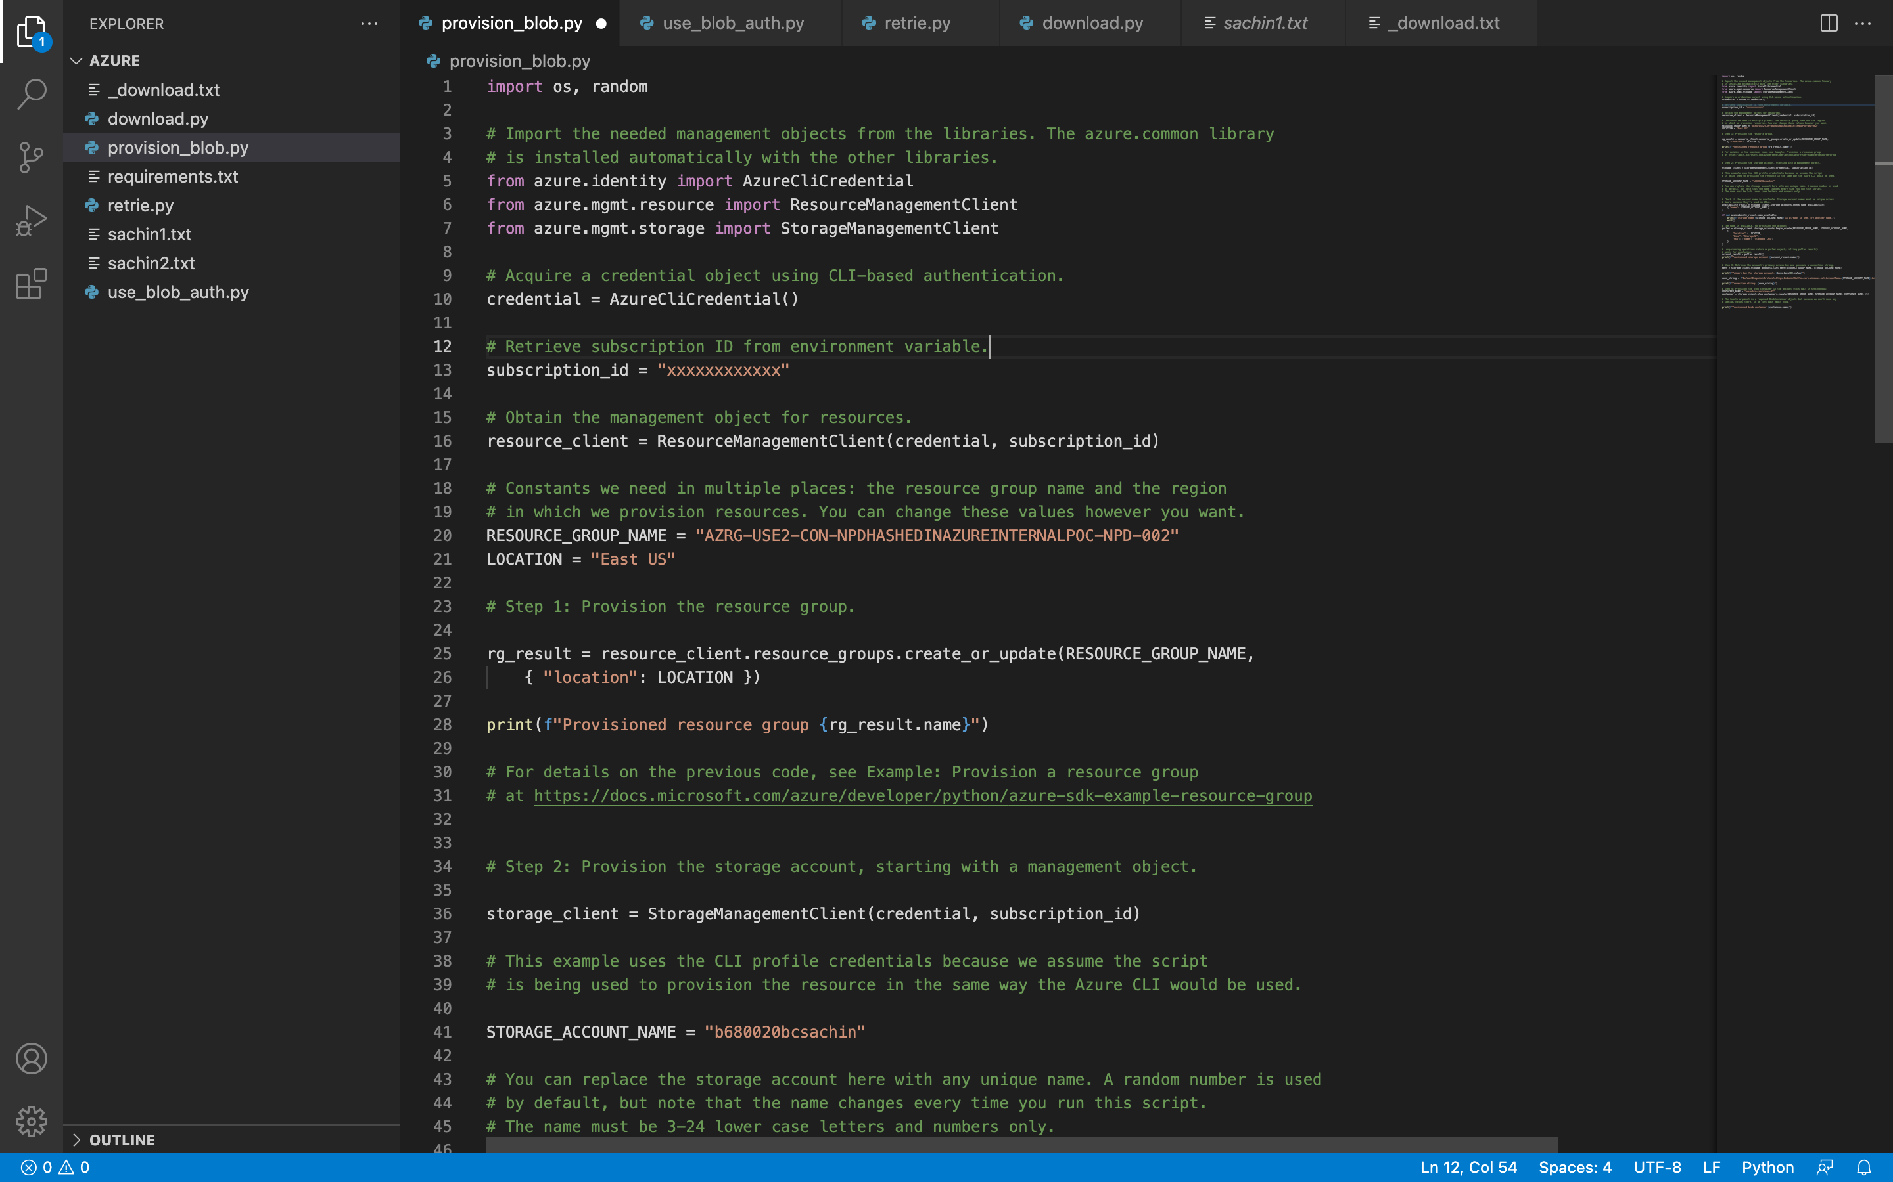

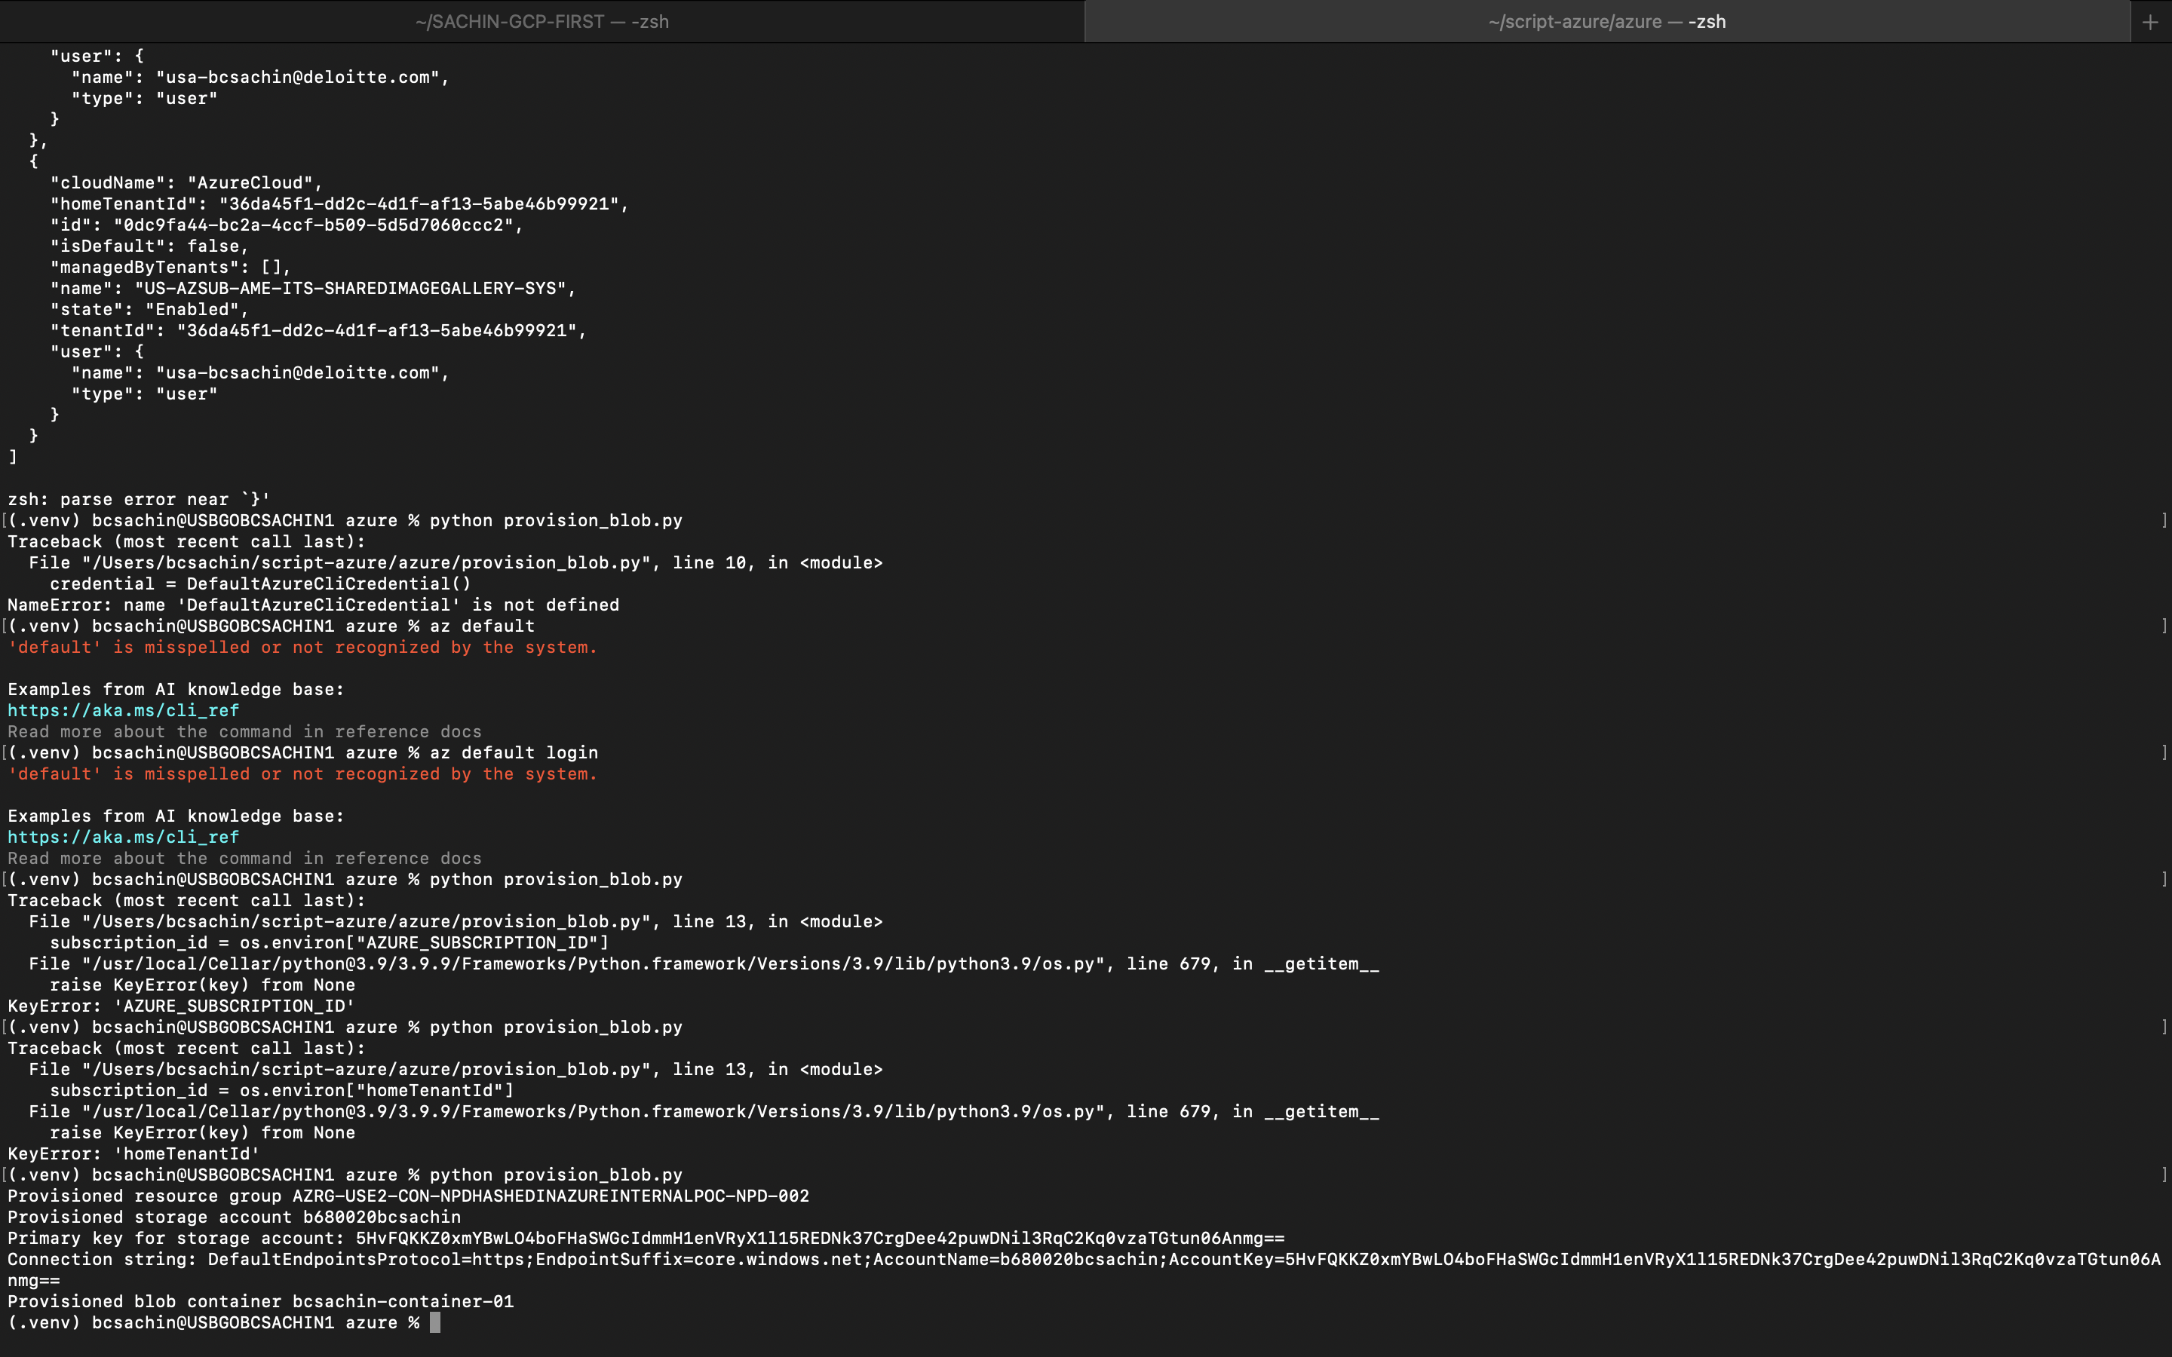

Storage account created

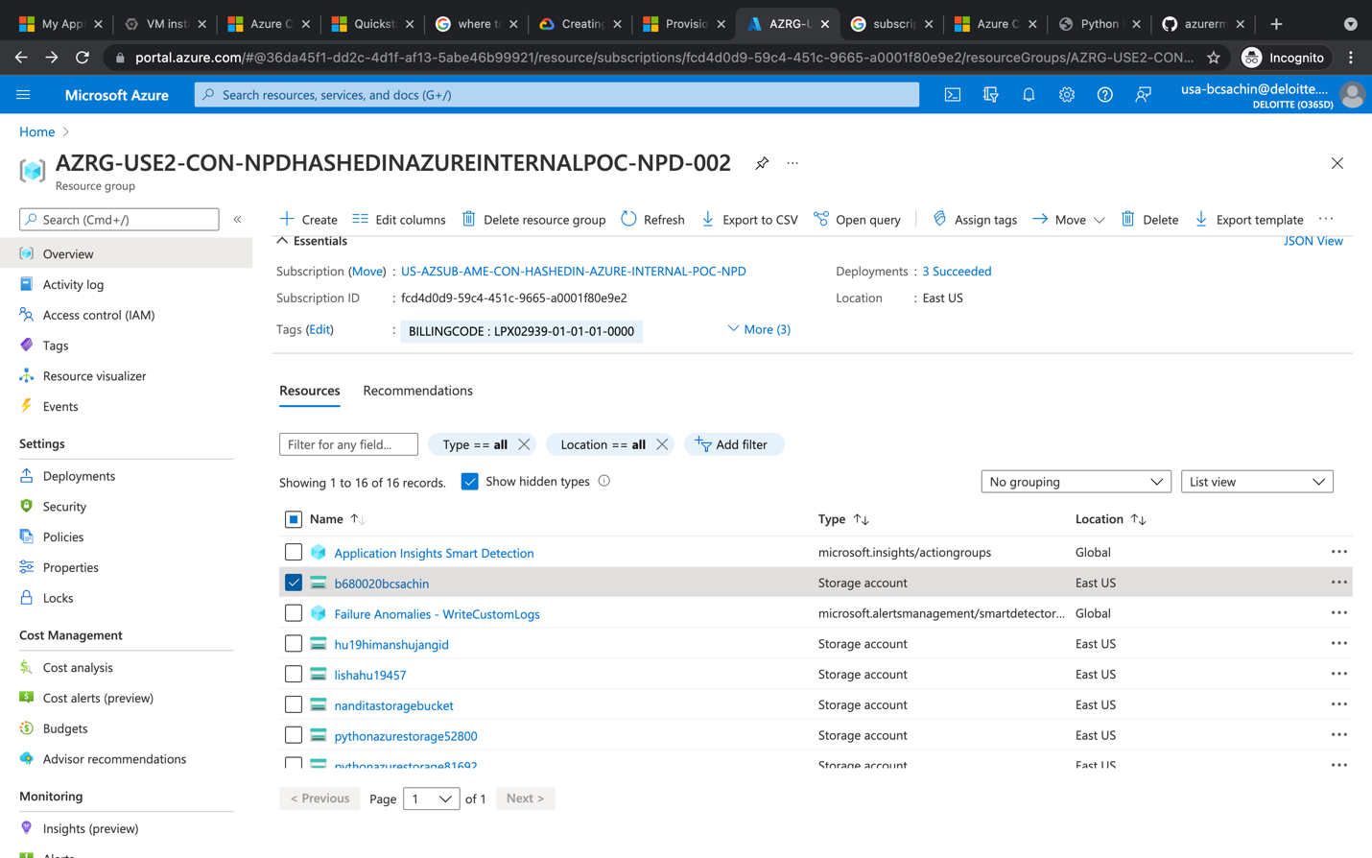

Container created

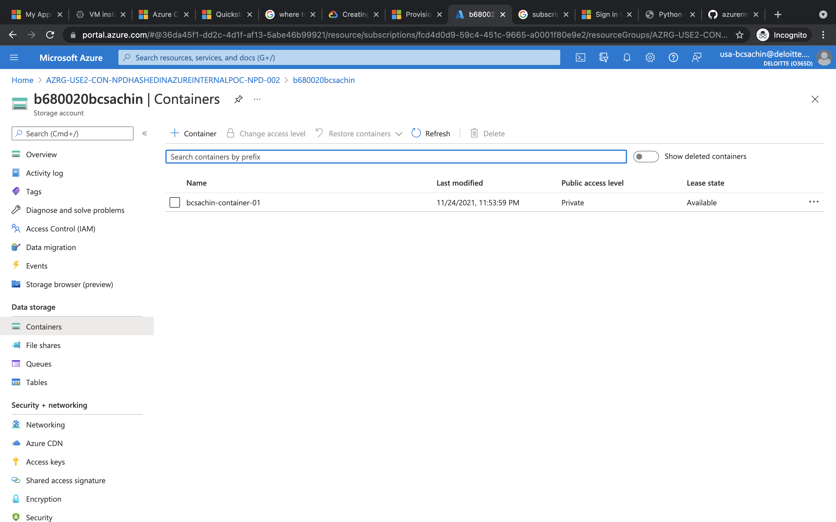

To upload

Follow upload.py.

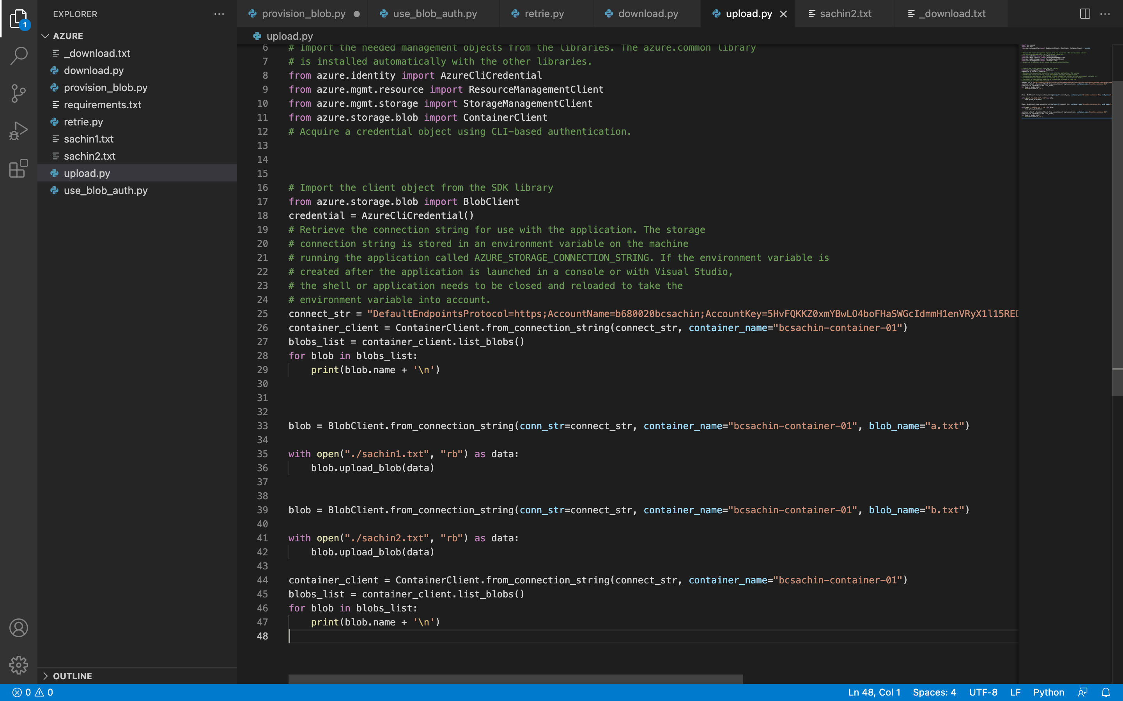

Here first list existing blob ->then upload->again list. To verify

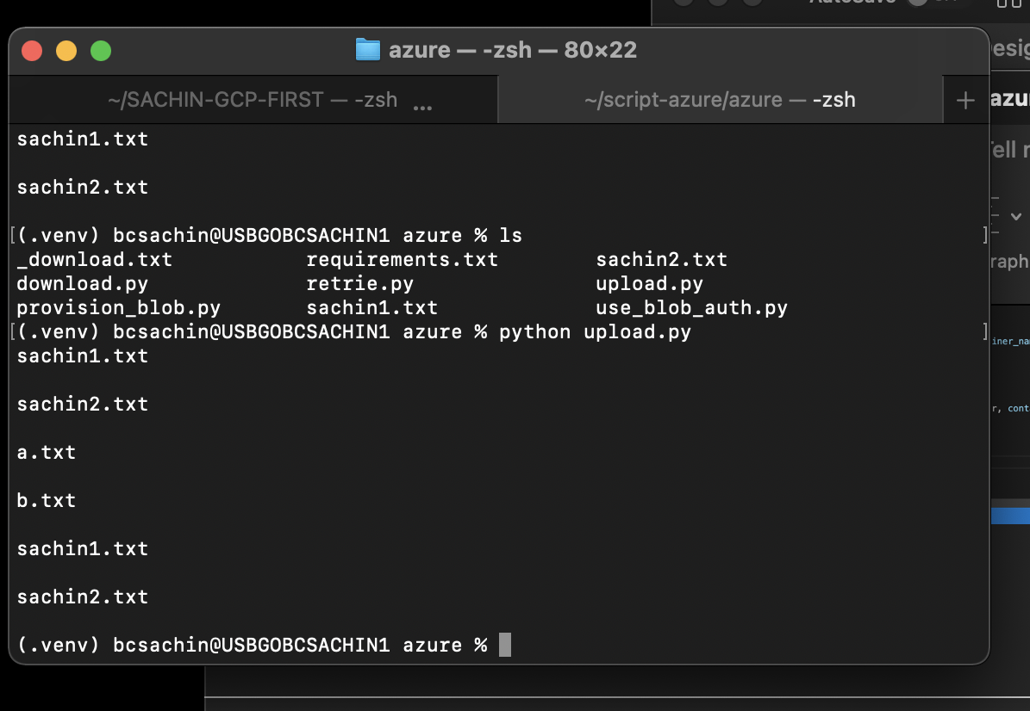

21.2

To list blobs follow retrieve.py given below

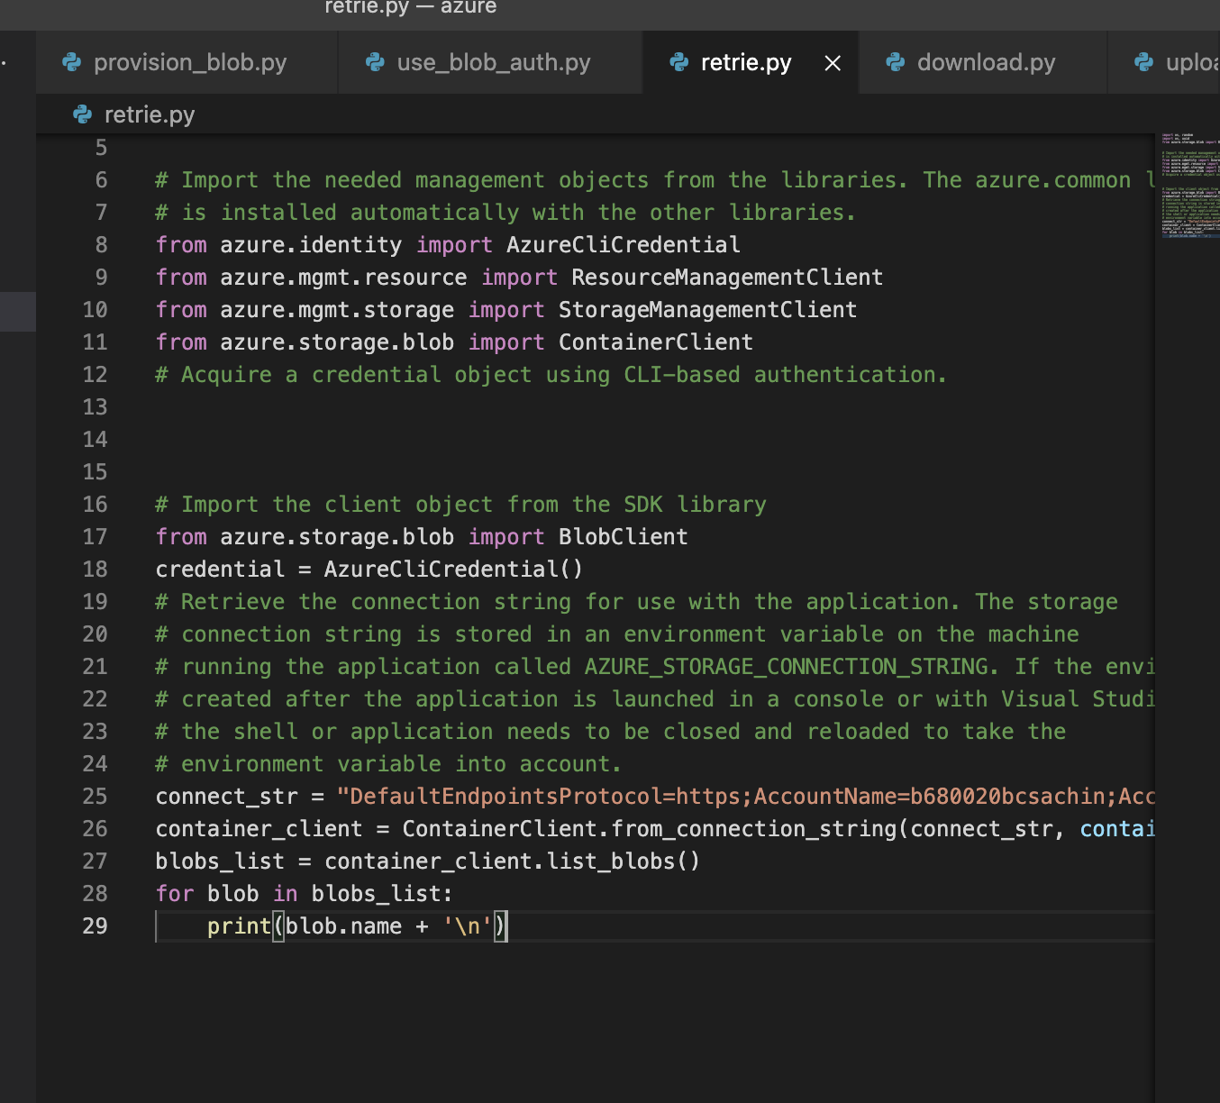

Result will be

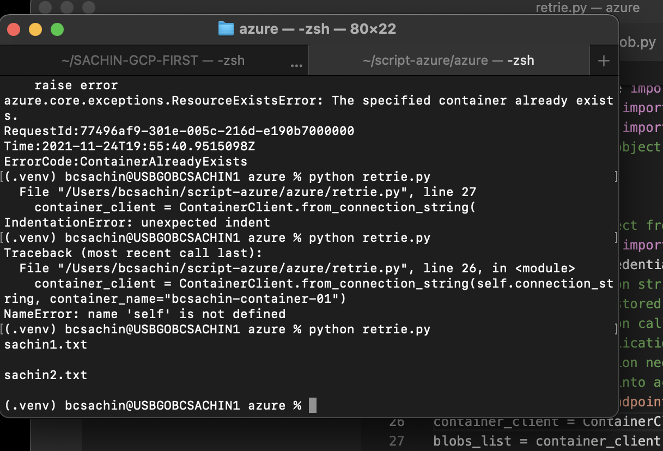

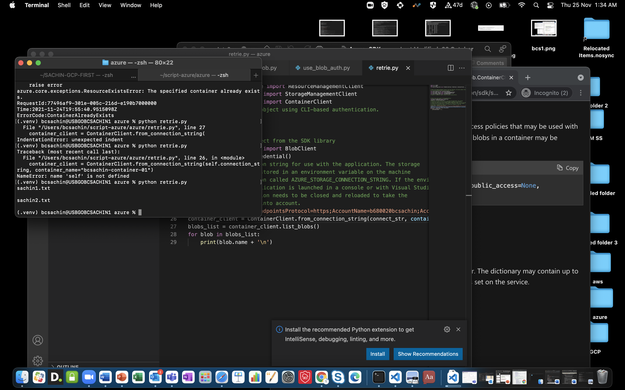

(.venv) bcsachin@USBGOBCSACHIN1 azure % python retrie.py

sachin1.txt

sachin2.txt

to download follow download.py

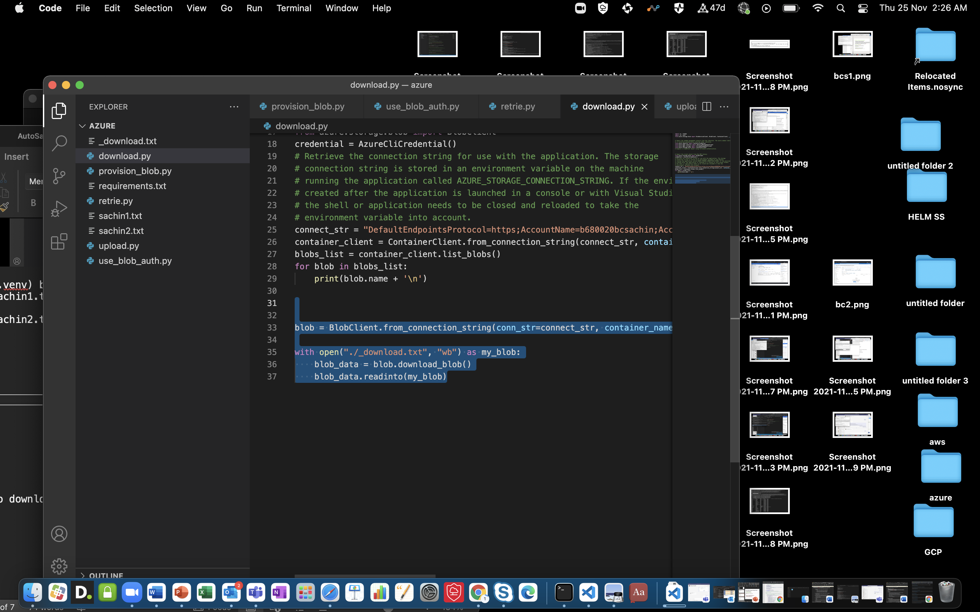

_DOWNLOAD.txt looks like

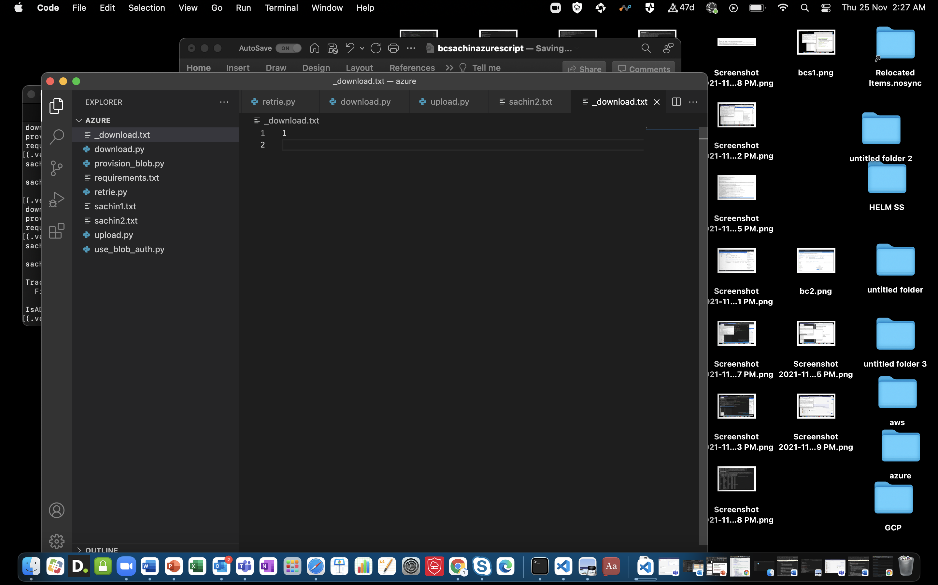

To delete

Blob.delete_blob()

If it returns none then it means successfully deleted

To delete container

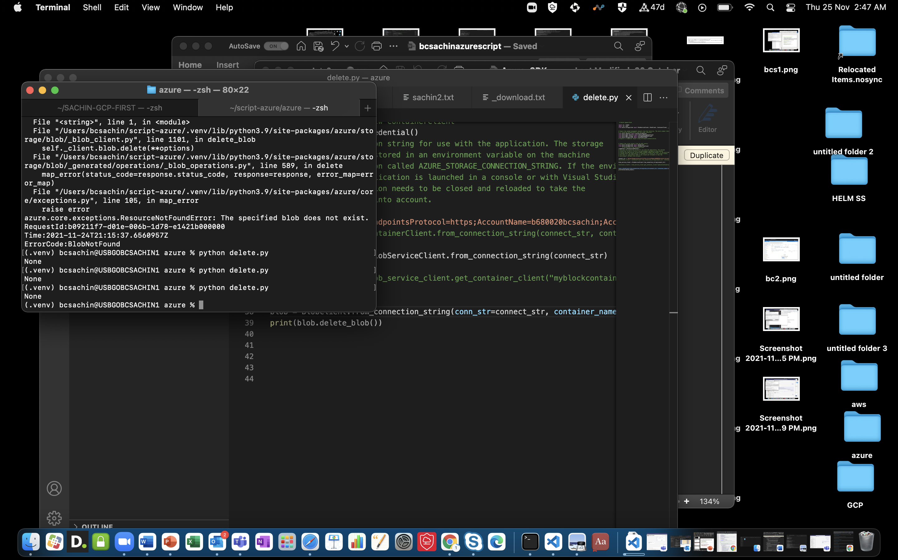

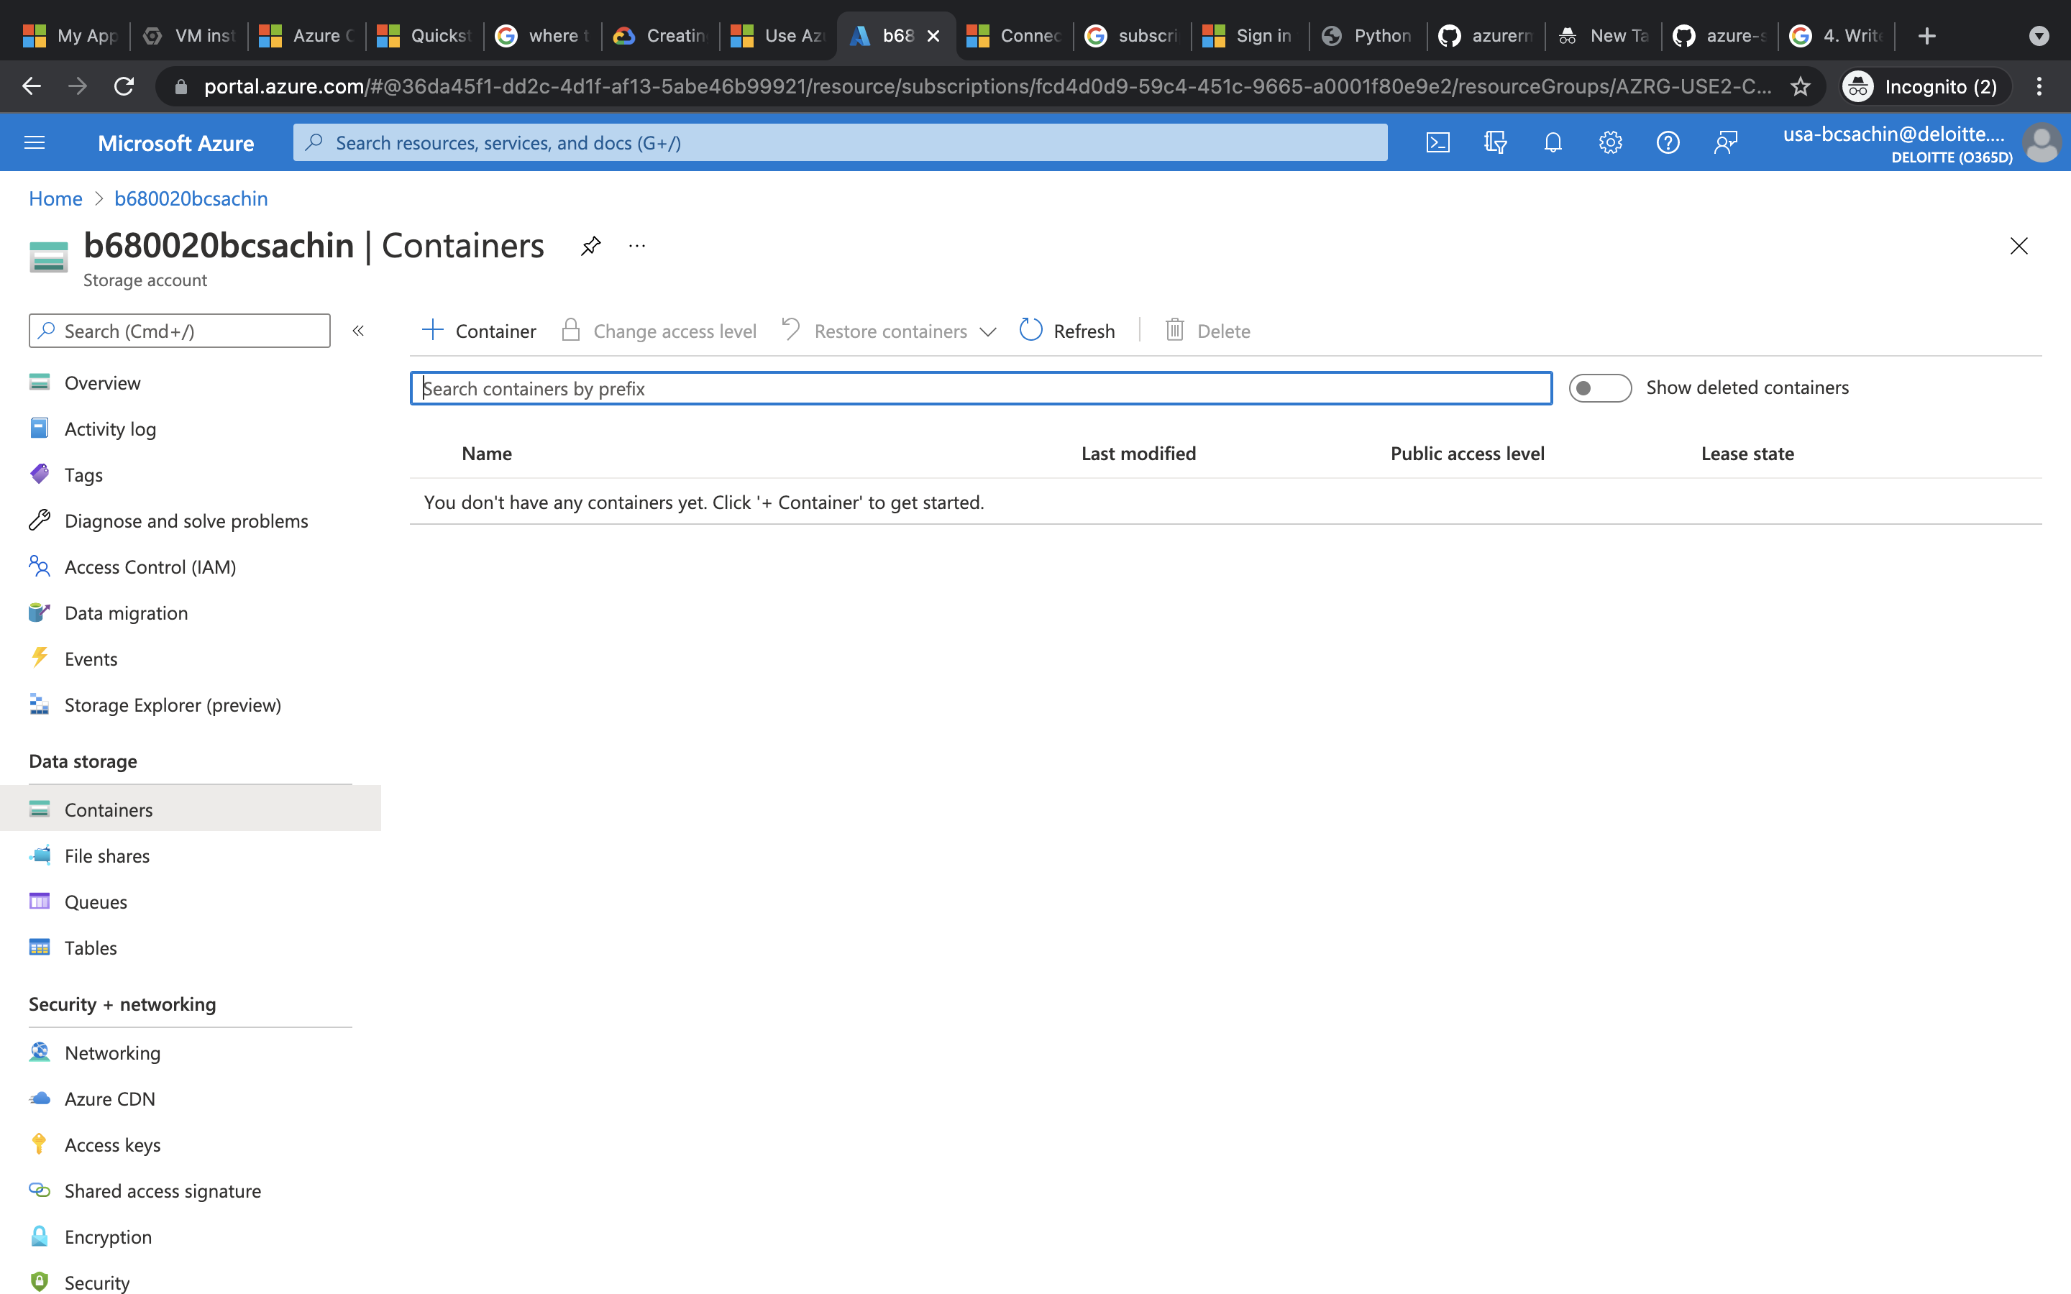

/////

Assignment 2

1.

Created provision_blob.py with VNET_NAME = "b680020bcsachinn-vnet"

SUBNET_NAME = "b680020bcsachinn-subnet"

IP_NAME = "b680020bcsachinn-ip"

IP_CONFIG_NAME = "b680020bcsachinn-ip-config"

NIC_NAME = "b680020bcsachinn-nic"

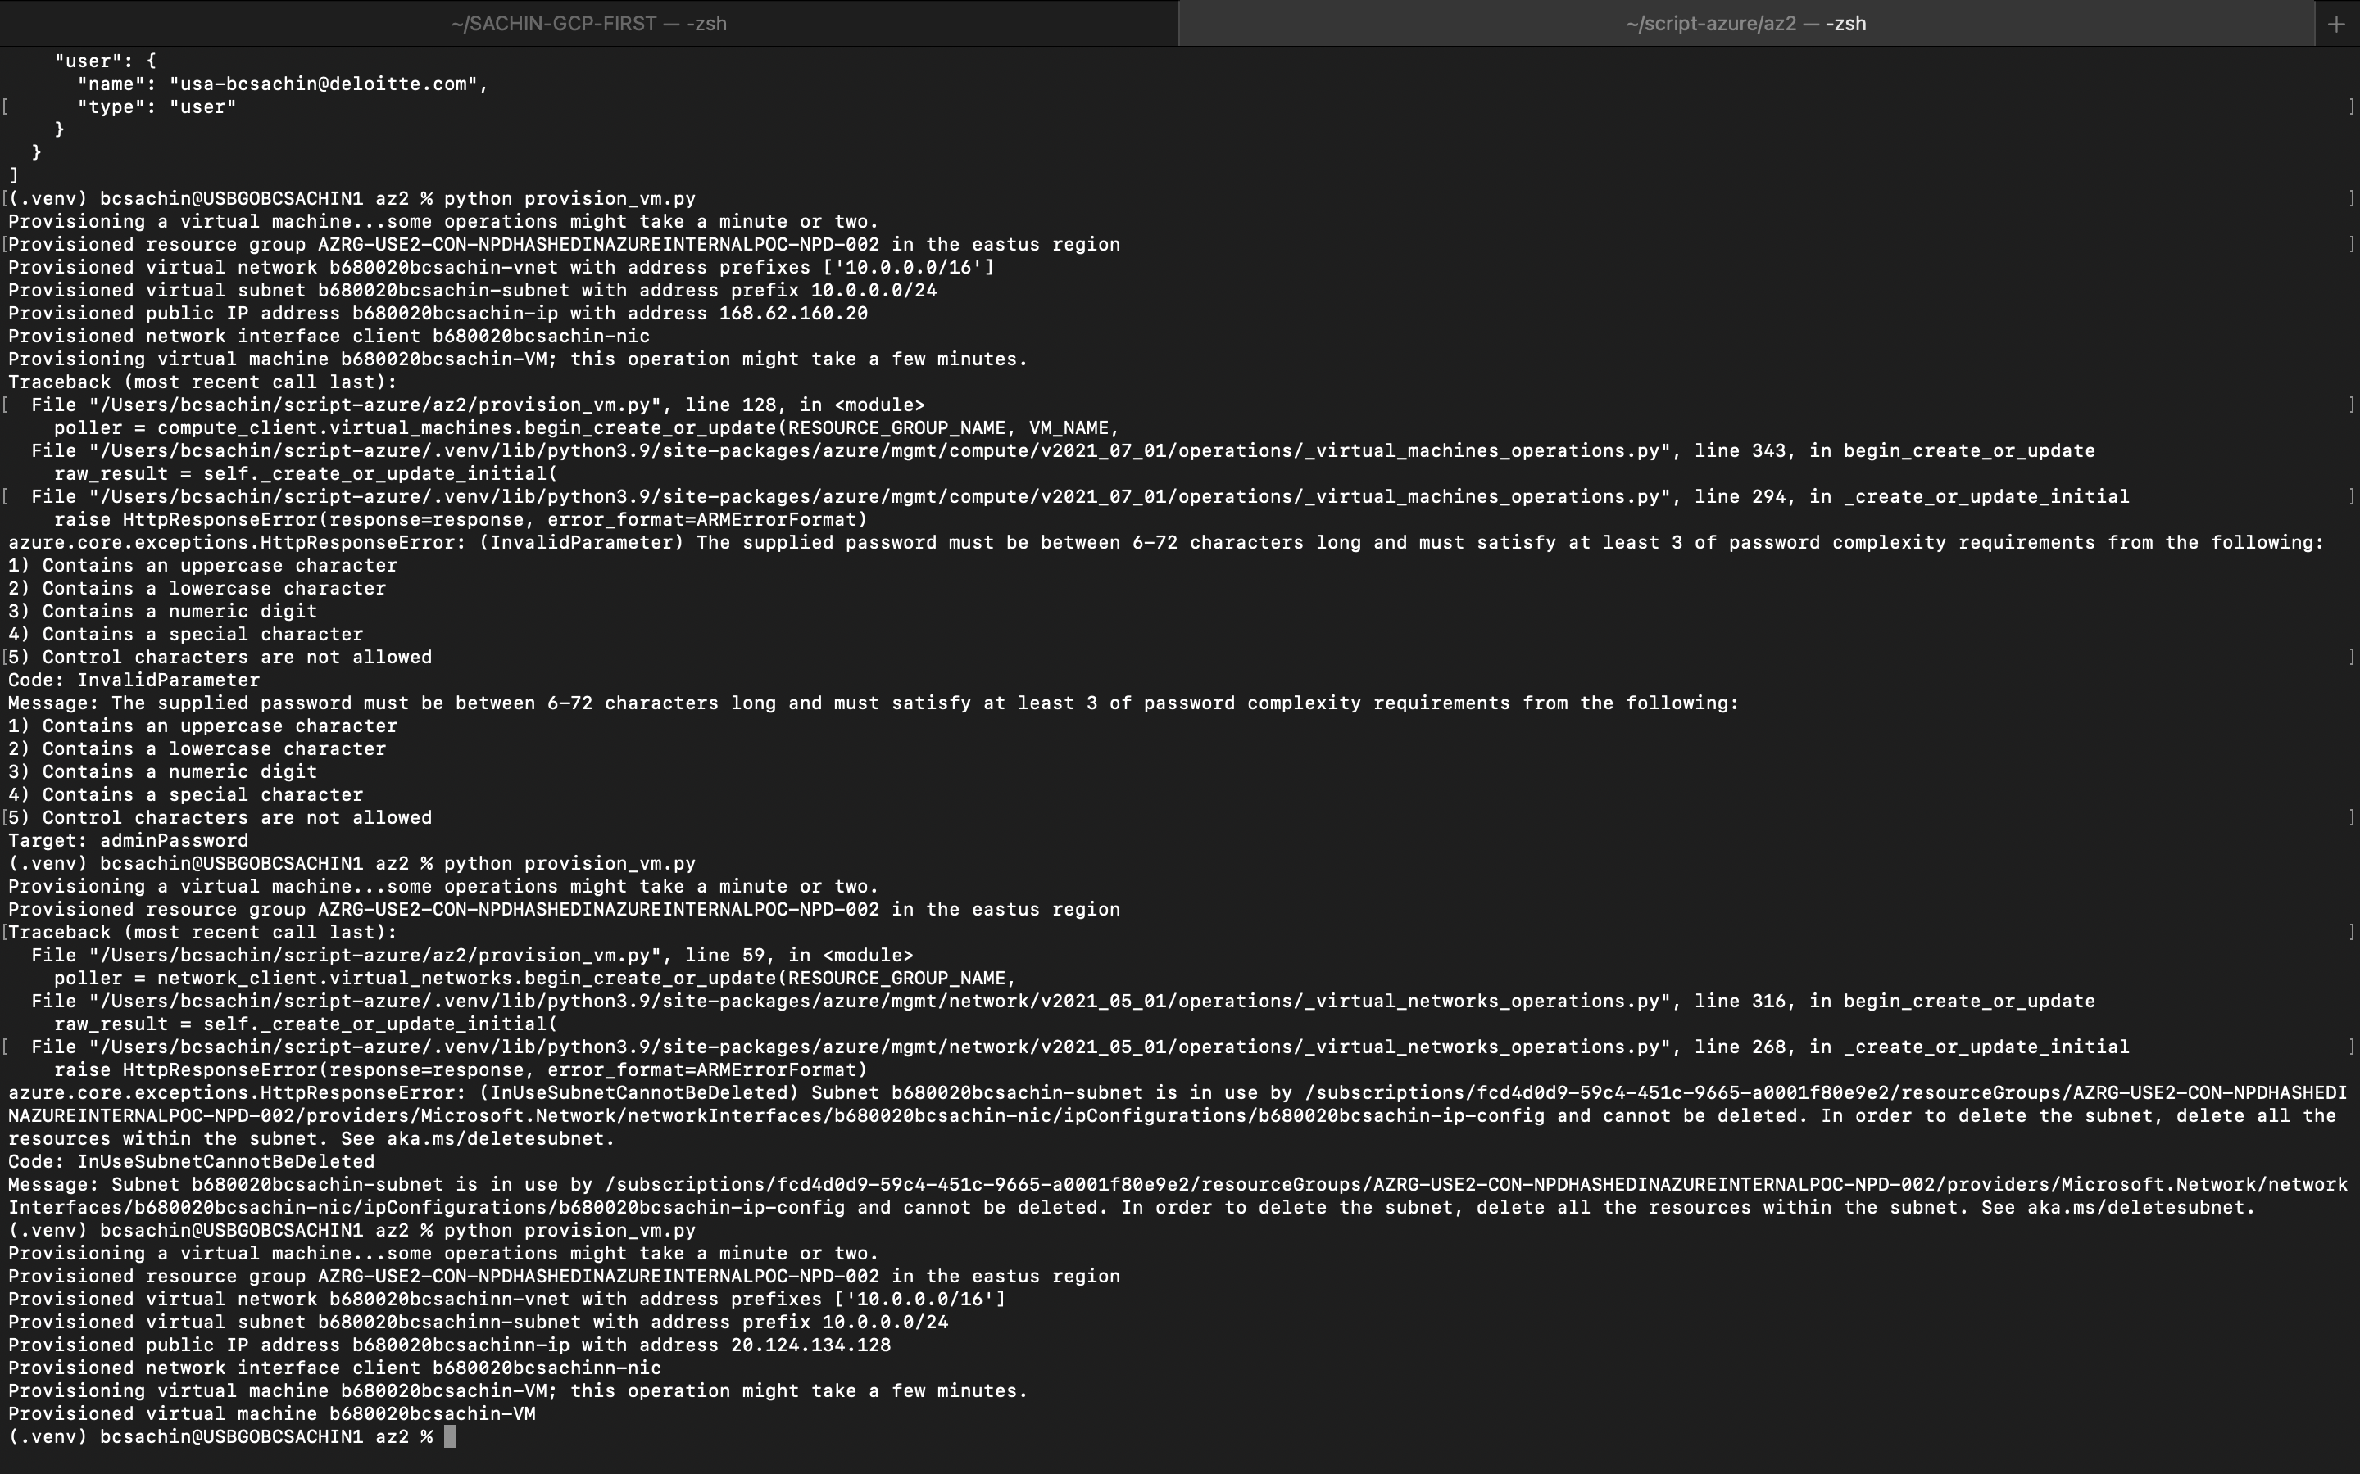

After creation

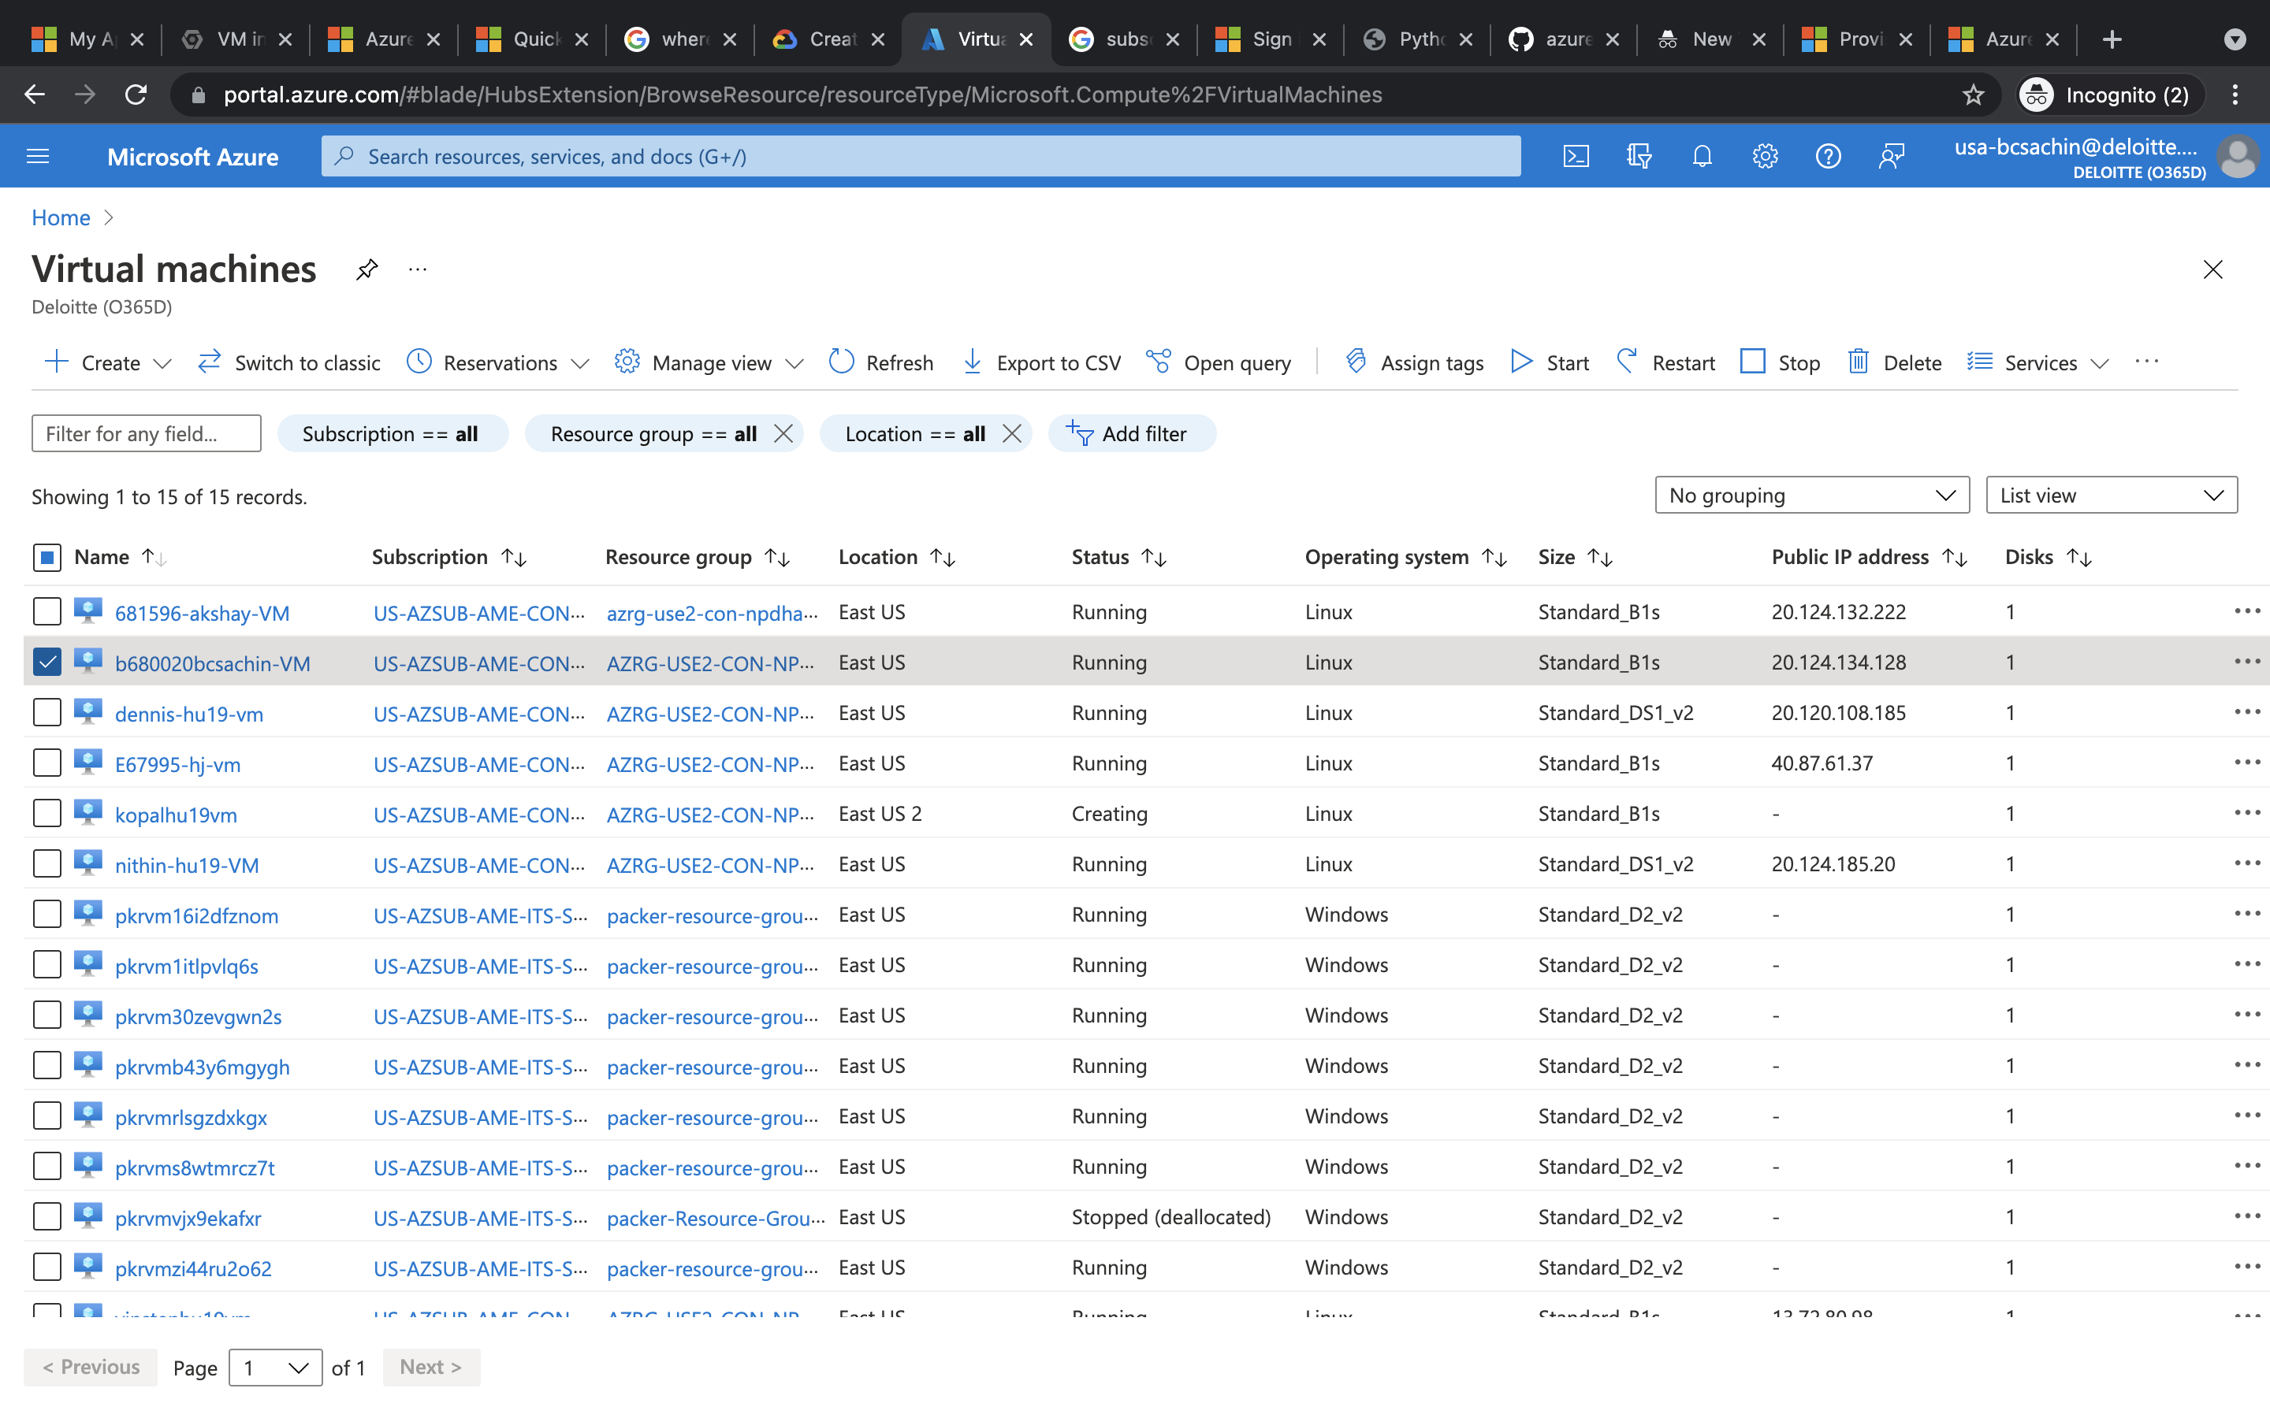

2.

List_all() function used to list all vm in subscription

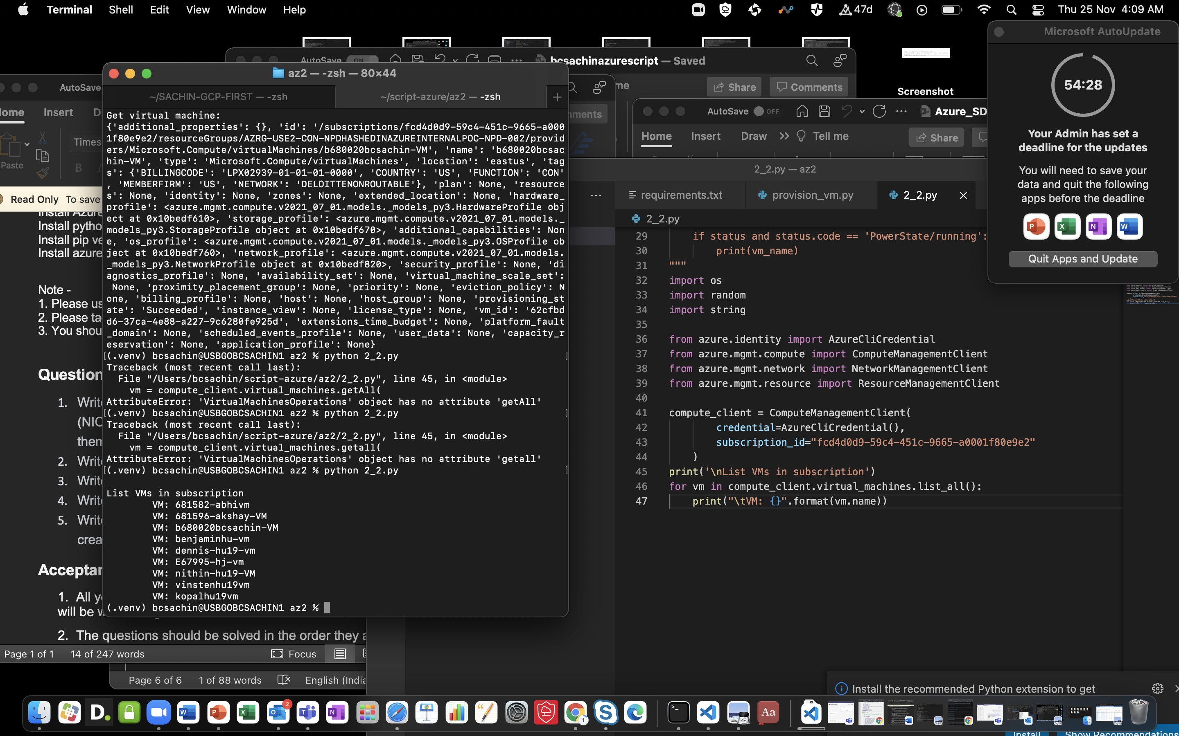

To stop vm

Begin_power_off() method used

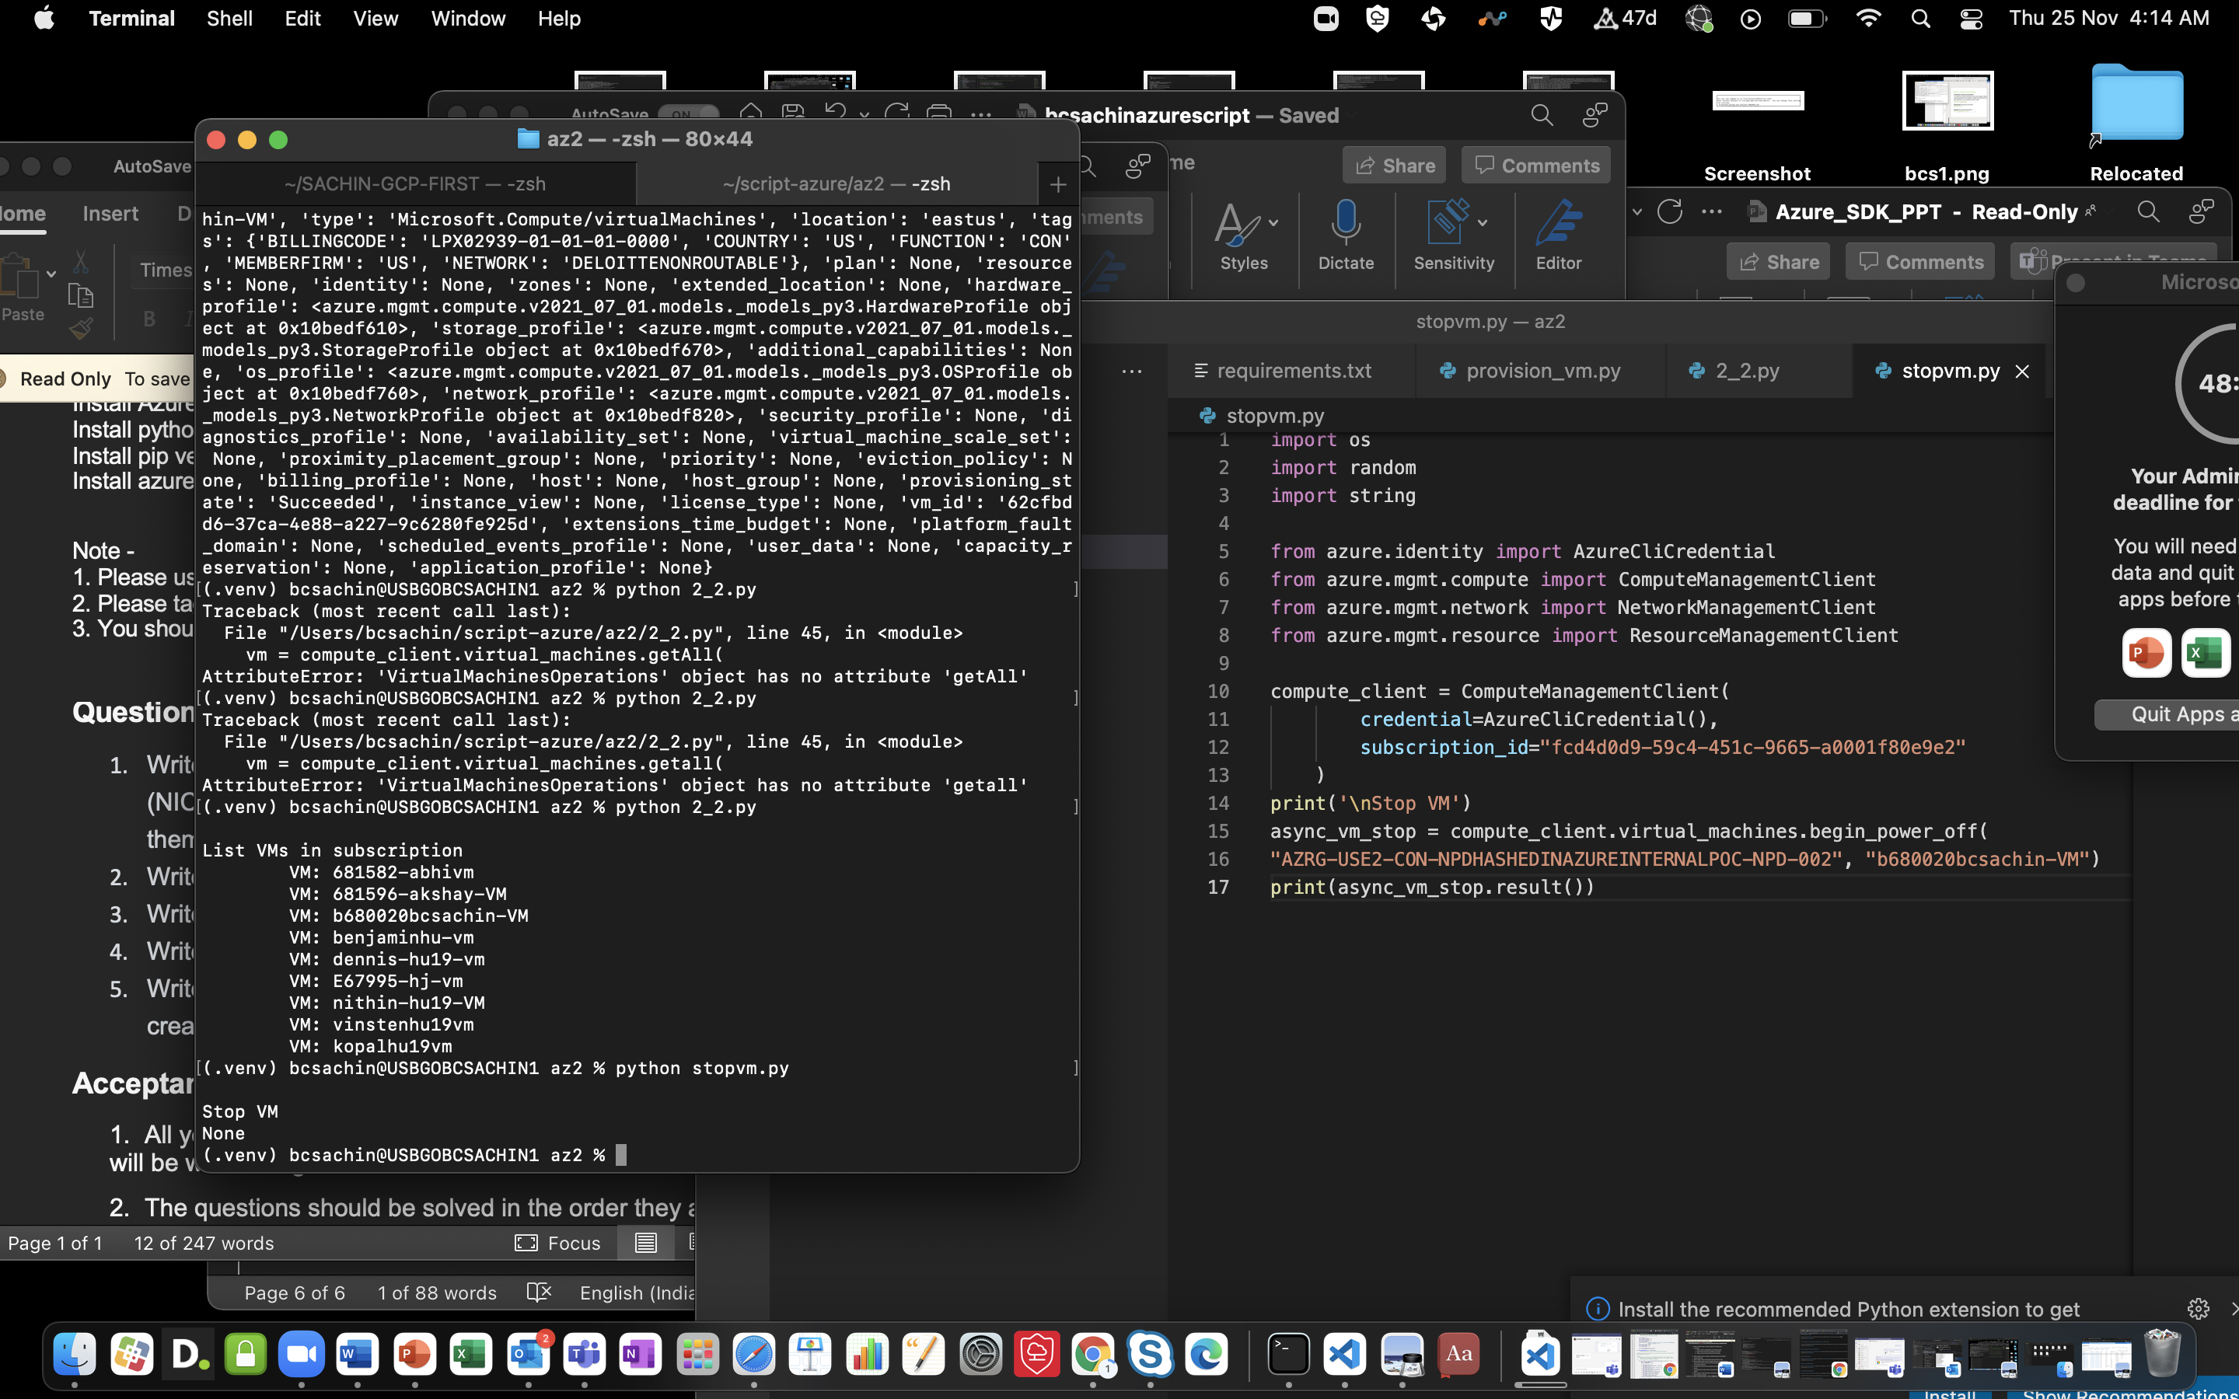

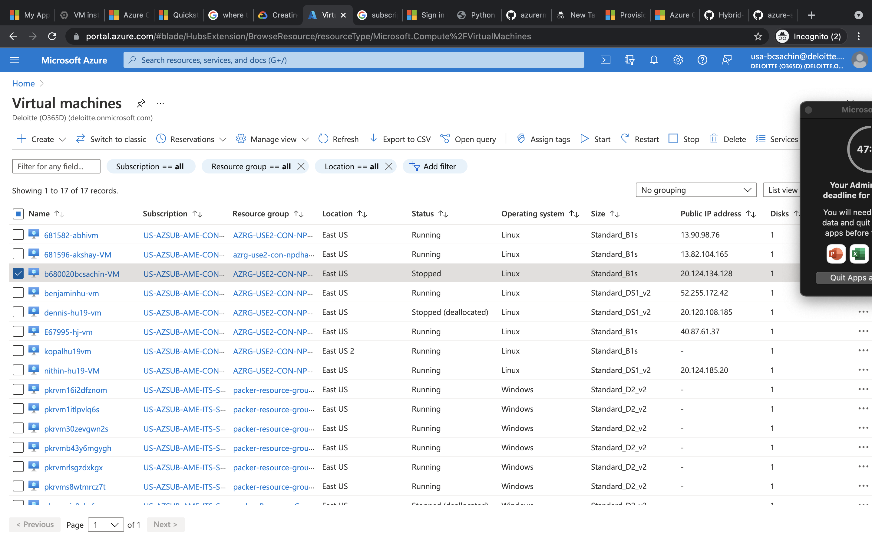

Start vm

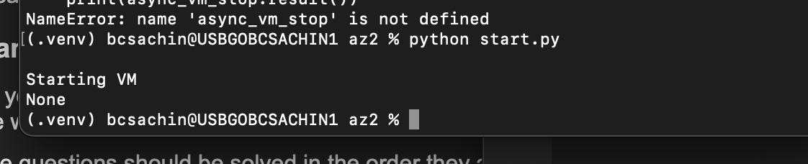

Script looks like

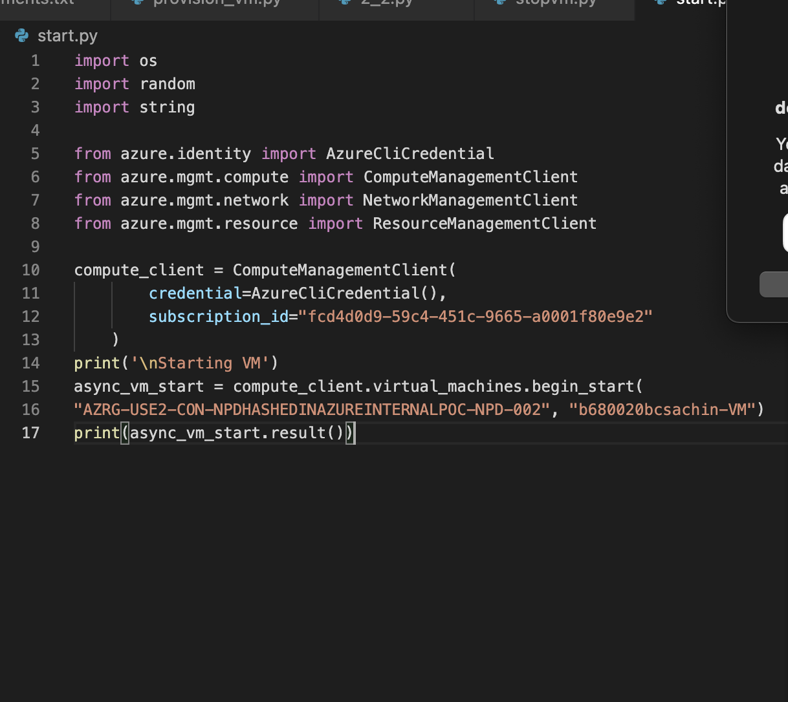

Now it is running

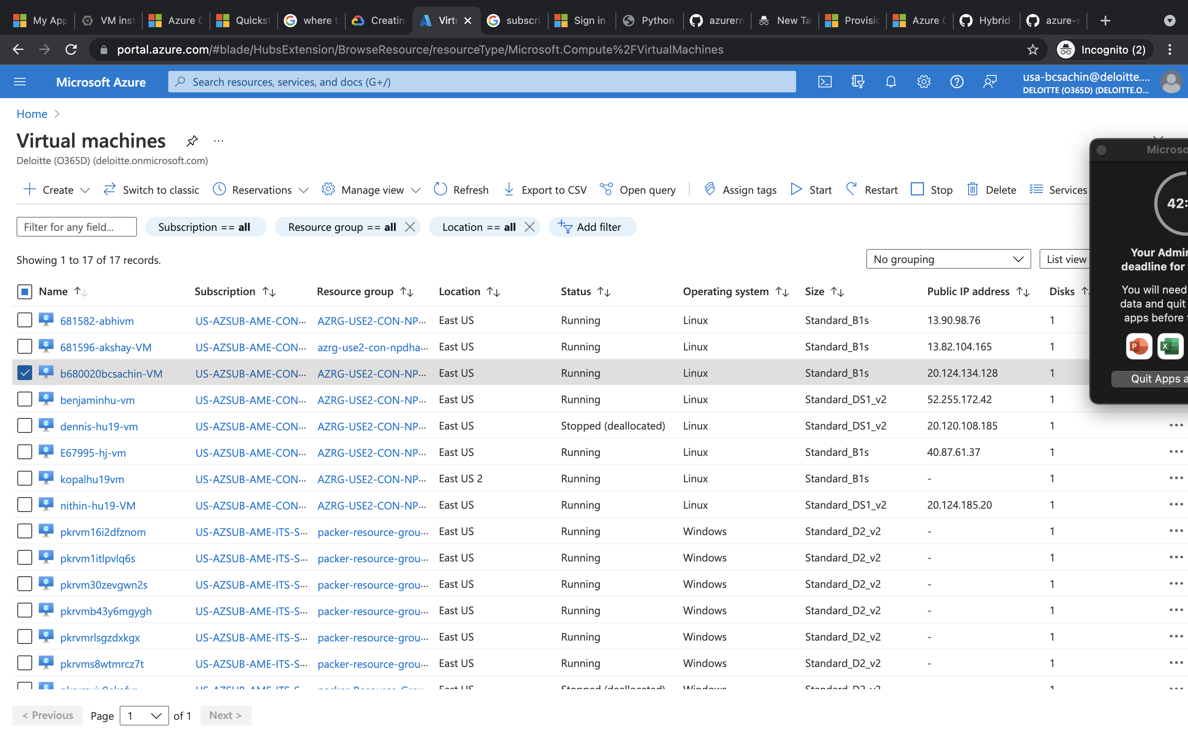

Deleting vm

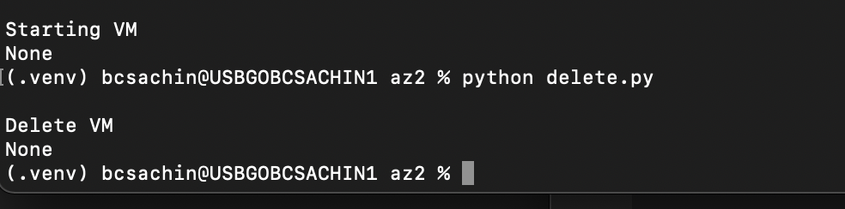

And delete.py looks like

